Mid-Norfolk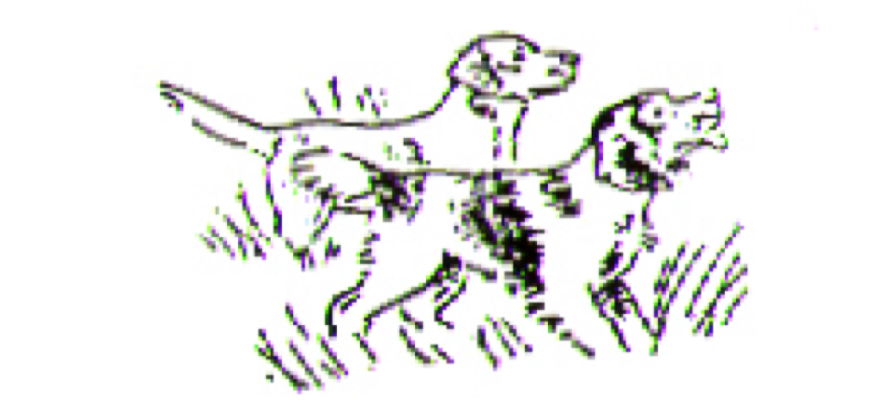Gundog Club

Kennel Club Identity Number 687

**OPEN A.V. RETRIEVER GUNDOG WORKING TEST**

**(Walked up in sugar beet)**

**On**

**Saturday 14th September 2024**

By Kind Invitation of Lord and Lady Fisher

at

**Kilverstone Estate, Thetford, Norfolk**

**0900 for 0930 start**

(Detailed directions and postcode for the meet point will be communicated separately after the draw)

**Judges**

TBC

**Entry Fees: Members £16*, non-Members £26, payable with entry form.**

Please return completed Entry Forms by email to: (**gwtsecretary**[@midnorfolkgundogs.co.uk](mailto:secretary@midnorfolkgundogs.co.uk)) by **midday Friday 6th September 2024.**

Exceptionally, Entry Forms may be returned by post by midday Friday 6th September 2024 to: Colin Walpole,

GWT Secretary, Holly Tree Lodge, Stratton Rd, Wacton, Norfolk, NR15 2UF

Payment with Entry please to be made to the Club Bank Account (Mid-Norfolk Gundog Club, Account Number 70618411, Sort Code 20-99-21). An incomplete or illegible entry form, as with non-payment, will be excluded from the draw. Applicants requiring a printed copy of the draw are to provide a self-seal sae.

*Notes :*

*1. This Open Gundog Working Test for All-Variety Retrievers will be held under Kennel Club Rules and Field Trial Regulations.*

*2. The draw will be held at 6.00pm on Friday 6th September 2024 at The Old Ram, Tivetshall, Norfolk. The result of the draw will be published on the Club website and communicated by email or print (where a stamped addressed envelope has been provided), to all submitting entries.*

*3. The Mid-Norfolk Gundog Club has the power to exclude any dog from the competition and the right to refuse an entry.*

*4. Substitution of dogs will not be allowed within 7 days of the competition.*

*5. If a dog is withdrawn within seven days of the Test the full entry fee will be forfeited unless notice of the withdrawal is accompanied by a Veterinary Surgeon's Certificate.*

*6. No person attending the competition may allow a bitch in season to be on the Test ground or to foul any ground to be used by competing dogs.*

*7. If, after consultation with the Judges, members of the Committee present consider a dog unfit to compete by reason of contagious disease or physical condition such a dog shall be required to be removed immediately from the ground. Any such case is liable to be reported to the Kennel Club.*

*8. All handlers are to carry out the instructions of the judges who are empowered to remove from the Test any dog whose handler does not obey them or willfully interferes with another competitor or his dog.*

*9. Handlers competing with more than one dog are to ensure they have assistance to control their dogs to avoid inconveniencing other competitors.*

*10. All persons attending the Test must consider themselves under the control of the Stewards and officials of the Club.*

*11. No dog shall wear a collar whilst competing.*

*12. No person shall carry out punitive correction or harsh handling at a GWT.*

*13. No competitor may withdraw their dog and leave the competition ground without informing the Chief Steward.*

*14. Photography and videography is not permitted without the consent of the landowner (or their representative) and the Chief Steward.*

*Please be advised the Club Membership year runs from 1st September to 31st August. To enter this Open GWT as a Member it is imperative your Annual Membership for the year 1st September 2024 to 31 August 2025 must be paid before the draw.

The club would appreciate your setting up an annually paid £10 Standing Order from 1st September 2024.

Colin Walpole GWT Secretary. For any questions or assistance please email as above or call 07770373442.